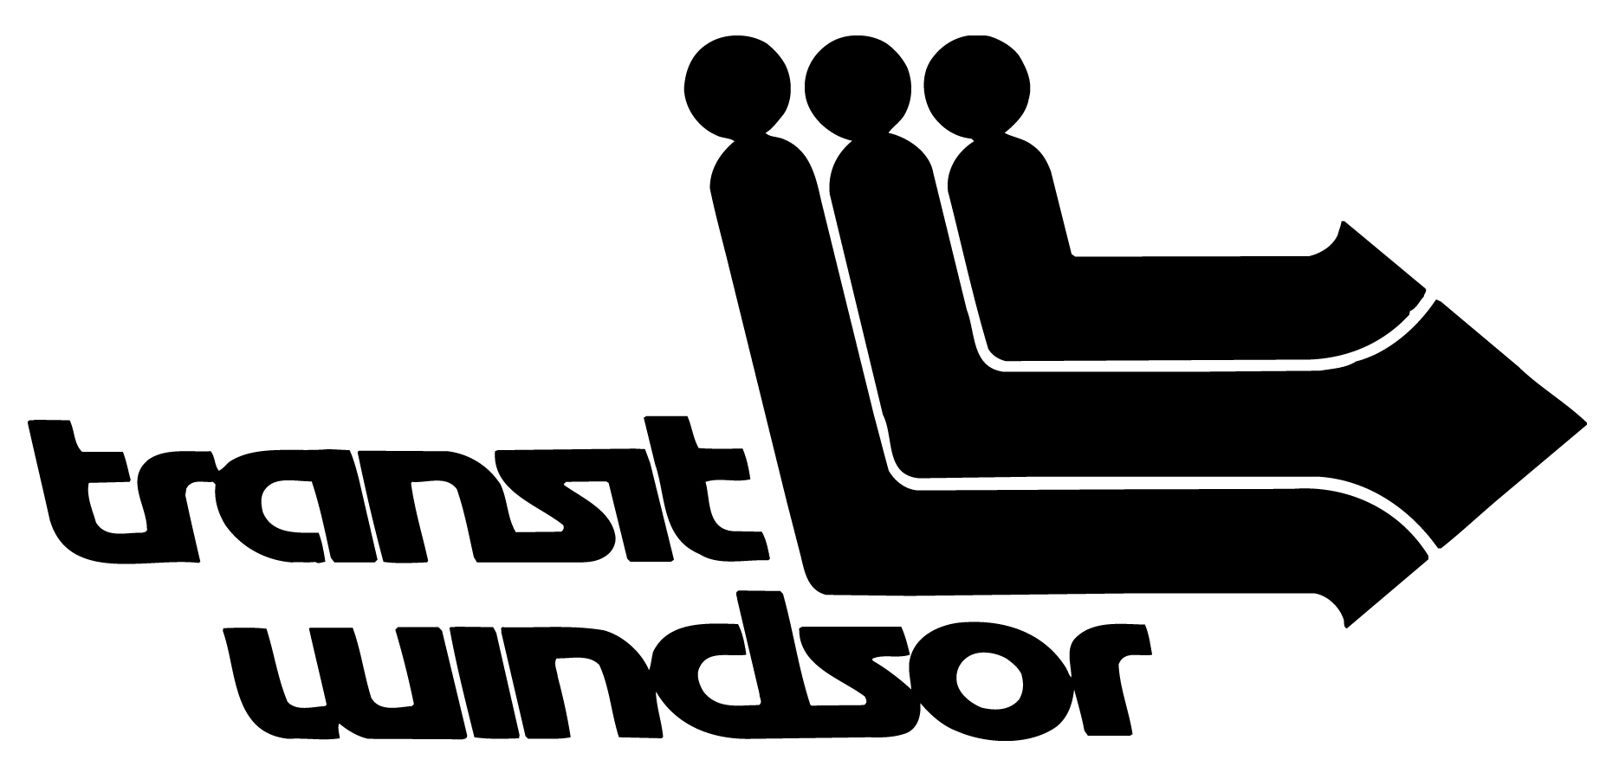
TRANSIT WINDSOR

MEDIA RELEASE

For Immediate Release
31 July 2026

OUELLETTE TRAFFIC DISRUPTION

WINDSOR, ONTARIO – A traffic disruption is scheduled to take place on Thursday, October 24, 2024 from 1:00 p.m. to 2:00 p.m. This disruption is to take place on Ouellette Avenue between Wyandotte Street and Park Street. The Transway 1A detour will begin at 1:00 p.m. on Thursday, October 24, 2024 and will last until 2:00 p.m. The following detour will be in effect for the Transway 1C:

Transway 1C
Eastbound

Windsor International Transit Terminal to
Right on Pitt to
Right on Ferry to
Right on Chatham to
Left on Victoria to
Left on Wyandotte to
Right on Ouellette to
Regular route

Transway 1C
Westbound

Regular route on Ouellette to
Left on Wyandotte to
Right on Pelissier to
Left on Chatham to
Regular route

Please note: Transit Windsor buses are not allowed to board or drop off passengers at bus stops in construction zones.
Please contact Transit Windsor’s customer service at 519.944.4111, or contact 311, to help with any questions. -30-

