**Meighen Heights**

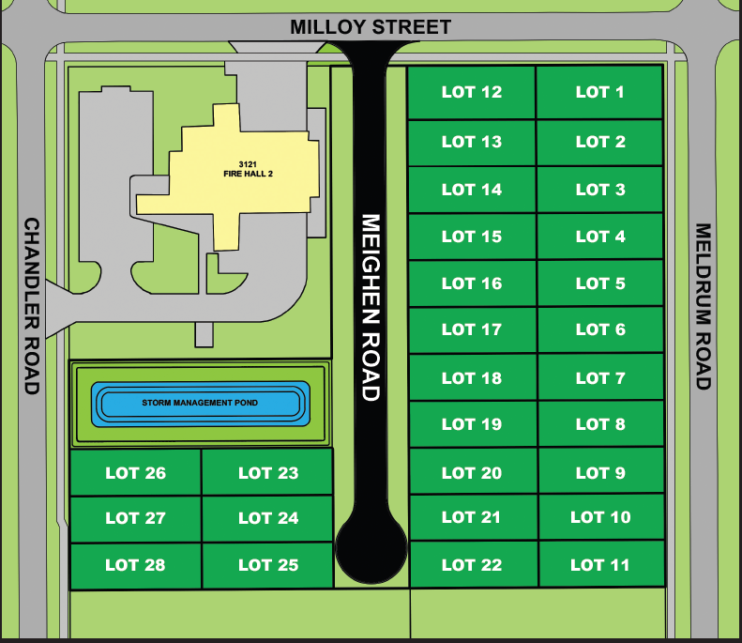

**SOLD**

**SOLD**

**SOLD**

**SOLD**

**SOLD**

**SOLD**

**SOLD**

**SOLD**

**SOLD**

**SOLD**

**SOLD**

**SOLD**

**SOLD**

**SOLD**

**SOLD**

**SOLD**

**SOLD**

**SOLD**

**SOLD**

**SOLD**

**SOLD**

**SOLD**

**SOLD**

**SOLD**

**SOLD**

**SOLD**

**Sold as of August 30, 2024**